Software Architecture

Team G

10/20/23

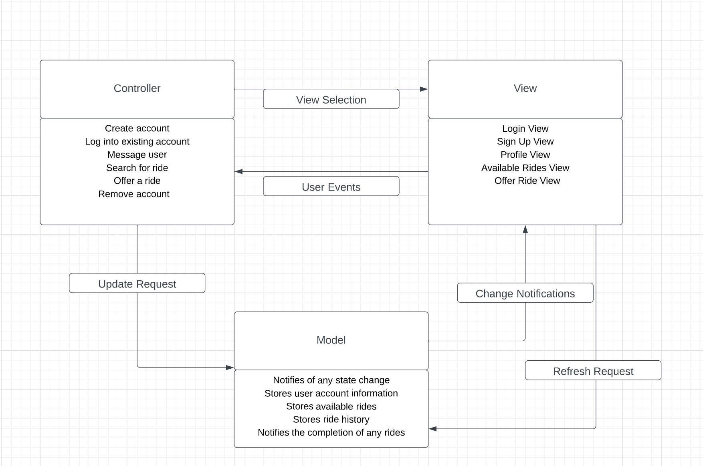

This architecture was chosen because it is simple, easy to understand, and effective. I worked off a template given to us which outlined the architecture for a shopping application. As our application involves many of the same attributes and features, it made sense to adjust the diagram to match the needs of our application.